**COFFEE STORE WEBAPPLICATION USING HTML , CSS & JAVASCRIPT**

A J-Component Report

in partial fulfillment of the degree

**Bachelor of Technology**

in

**Computer Science & Engineering**

**By**

2003A51013 - Rimsha Mujeeb

2003A51019 - Finza Tazeen

2103A51L31 - Rikkula Rajkumar

**Under the Guidance of**

**Mr. K. Ravi Chythanya**

Assistant Professor

**Submitted to**



**SCHOOL OF COMPUTER SCIENCE & ARTIFICIAL INTELLIGENCE**

# December, 2021.

**SCHOOL OF COMPUTER SCIENCE & ARTIFICIAL INTELLIGENCE**

**CERTIFICATE**

This is to certify that the Minor Project Report entitled “***COFFEE STORE WEBAPPLICATION***” is a record of bonafide work carried out by the student(s) ***Rimsha Mujeeb , Finza Tazeen , Rikkula Rajkumar*** bearing Roll No(s) ***2003A51013 , 2003A51019 , 2103A51L31*** during the academic year 2021-22 in partial fulfillment of the award of the degree of **Bachelor of Technology** in **Computer Science & Engineering** by the SR University, Ananthasagar.

**Supervisor Head of the Department**

**ACKNOWLEDGEMENT**

We take this opportunity to express my profound gratitude and deep regards to our guide **Mr. Kanegonda Ravi Chythanya** sir and our HOD **Dr M.Sheshikala** mam who gave our team the opportunity to do this wonderful project on the topic **Coffee** **Store Webapplication** **using Html, Css and Javascript** . We thank my guide for his exemplary guidance, monitoring and constant encouragement throughout the course of this thesis. The blessing, help and guidance given by him time to time shall carry us a long way in the journey of life on which we were about to embark.

The project helped us learn how to do proper Research and we learned about many new things while doing the project. I also thank my team members for their constant encouragement to complete this project within the deadline.

**ABSTRACT**

Our application is to help a coffee store (café) owners

develop a professional website for marketing and easy management.

The web application is simple and easy to navigate thus User

Friendly. It also has café’s menu, review section, and an optional

online reservation option to help customers reserve their table in

advance .

Almost 80% of the population are coffee lovers. Our café is

Guaranteed to become the daily necessity for all the coffee addicts. A place

with good ambience where people can escape from their daily stress and

cherish with a cup of coffee. Our café has a spectacular interior designs

with stupendous taste of coffee. We have attached our menu which contains

different smoothies at attractive prices.

**TABLE OF CONTENTS**

|  |  |  |
| --- | --- | --- |
| **S. No** | **Title** | **Page. no** |
|  | Abstract | 4 |
| 1 | Introduction | 6 |
| 2 | Requirement Specification | 7 |
| 3 | Implementation | 8 |
| 4 | Testing | 14 |
| 5 | Results | 15 |
| 6 | Conclusion | 18 |
| 7 | Future Scope | 19 |
| 8 | Bibliography | 20 |

**INTRODUCTION**

This project is about coffee store web application using html, css and

javascript. Coffee is one of the drinks favored by people in all over the world.

The hobby of drinking coffee causes people to be able to make coffee as a

favorite drink or continuously drink coffee because it is considered as a

reliever of drowsiness and giving stimulus before carrying out activities

during the day.

Our web application has a simple , seamless and user friendly design.

Some of the features of this website include :

Website home section with image slider

AboutUs café contact information

A MENU that is easy to follow / navigate

A consumers Reviews section on the café drinks

Photos related to our coffee store

An option for consumers to book / reserve their table

**REQUIREMENT SPECIFICATIONS**

* **About us –** café’s contact information

Location of the place

Our branches

* **Menu –** Customers can search menu according to price range and category as well.
* **Review –** An honest review section for browsing users
* **Allow to book –** Customers are allowed to reserve the table in advance instead of waiting in the store
* **Photos –** Photos related to our store , different coffees , smoothies for first time user.
* Closing and opening timings of store.

**IMPLEMENTATION**

<html >

<head>

<meta charset="UTF-8">

<meta http-equiv="X-UA-Compatible" content="IE=edge">

<meta name="viewport" content="width=device-width, initial-scale=1.0">

<title>coffee website</title>

<link rel="stylesheet" type="text/css" href="style.css">

<link rel="stylesheet" href="https://unpkg.com/swiper@7/swiper-bundle.min.css" />

<link rel="stylesheet" href="https://cdnjs.cloudflare.com/ajax/libs/font-awesome/5.15.4/css/all.min.css">

<link rel="stylesheet" type="text/javascript" href="script.js">

@import

url('https://fonts.googleapis.com/css2?family=Poppins:wght@100;300;400;500;600&display=swap');

body{

background-color:lightsteelblue;

}

:root{

--main-color:#443;

--border-radius:95% 4% 97% 5%/4% 94% 3% 95%;

--border-radius-hover:4% 95% 6% 95%/95% 4% 92% 5%;

--border:.2rem solid var(--main-color);

--border-hover:.2rem dashed var(--main-color);

}

*{

font-family: 'Poppins', sans-serif;

margin:0; padding:0;

box-sizing: border-box;

outline: none; border:none;

text-decoration: none;

text-transform: capitalize;

transition: all .2s linear;

}

html{

font-size: 62.5%;

overflow-x: hidden;

scroll-padding-top: 7rem;

scroll-behavior: smooth;

}

section{

padding:2rem 9%;

}

.heading{

font-size: 9rem;

text-transform: uppercase;

color:transparent;

-webkit-text-stroke: .05rem var(--main-color);

letter-spacing: .2rem;

text-align: center;

pointer-events: none;

position: relative;

}

.heading span{

position: absolute;

top:50%; left:50%;

transform: translate(-50%, -50%);

width: 100%;

color:var(--main-color);

font-size: 3rem;

}

.btn{

display: inline-block;

padding:.9rem 1.5rem;

border-radius: var(--border-radius);

color:var(--main-color);

background: none;

border:var(--border);

cursor: pointer;

margin-top: 1rem;

font-size: 1.7rem;

}

.btn:hover{

border-radius: var(--border-radius-hover);

border:var(--border-hover);

}

.header{

position: fixed;

top:0; left: 0; right: 0;

display: flex;

align-items: center;

justify-content: space-between;

z-index: 1000;

background:black;

color:white;

box-shadow: 0 .5rem 1rem rgba(0,0,0,.1);

padding:2rem 9%;

}

.header .logo{

color:white;

font-size: 2.3rem;

}

.header .logo i{

padding-left: .5rem;

}

.header .navbar a{

margin:0 1rem;

font-size: 1.7rem;

color:white;

}

.header .navbar a:hover{

color:yellowgreen;

}

.header .btn{

margin-top: 0;

color:white;

}

</head>

<body>

<header class="header">

<div id="menu-btn" class="fas fa-bars"></div>

<a href="#" class="logo"> coffee <i class="fas fa-mug-hot"></i> </a>

<nav class="navbar">

<a href="index.html">home</a>

<a href="#about">about</a>

<a href="#menu">menu</a>

<a href="#review">review</a>

<a href="PP.HTML">photos</a>

</nav>

<a href="#book" class="btn">book a table</a>

</header>

<section class="home" id="home">

<div class="row">

<div class="content">

<h3>fresh coffee in the morning</h3>

<a href="#menu" class="btn">buy one now</a>

</div>

<div class="image">

<img src="home-img-2.png" class="main-home-image" alt="">

</div>

</div>

<div class="image-slider">

<img src="home-img-1.png" alt="">

<img src="home-img-2.png" alt="">

<img src="home-img-3.png" alt="">

</div>

</section>

</body>

</html>

**TESTING**

**WEBSITE HOMEPAGE:**

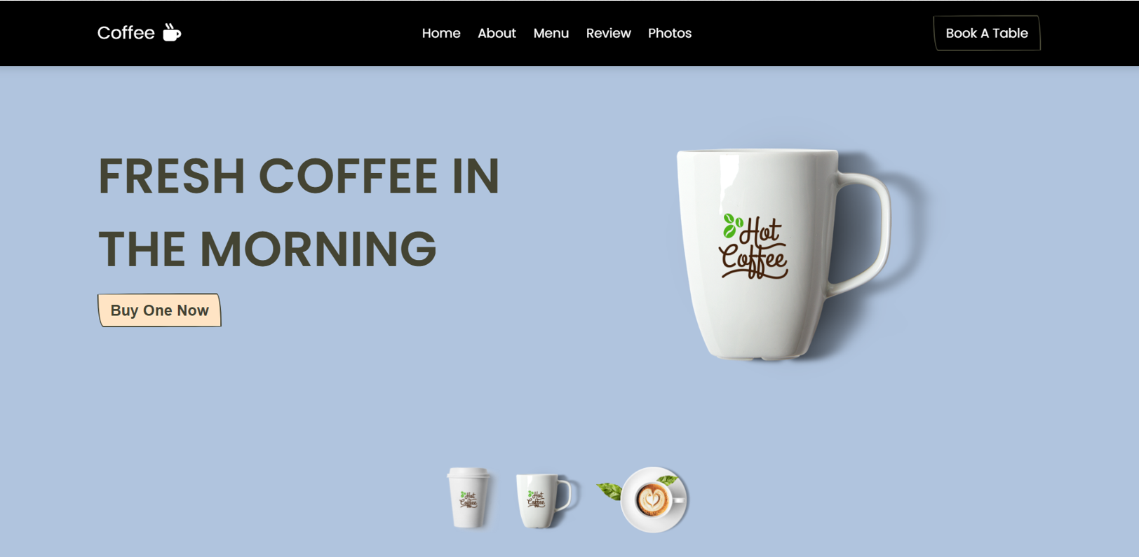

**RESULTS**

**ABOUT US PAGE:**

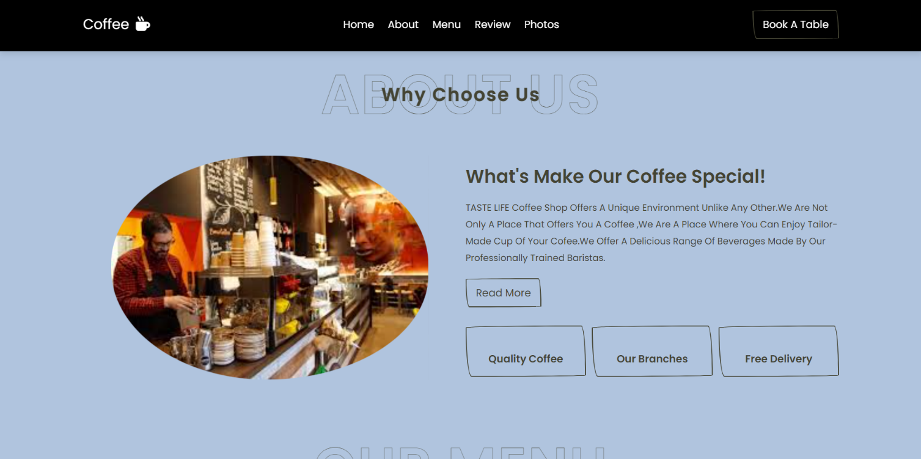

**MENU PAGE:**

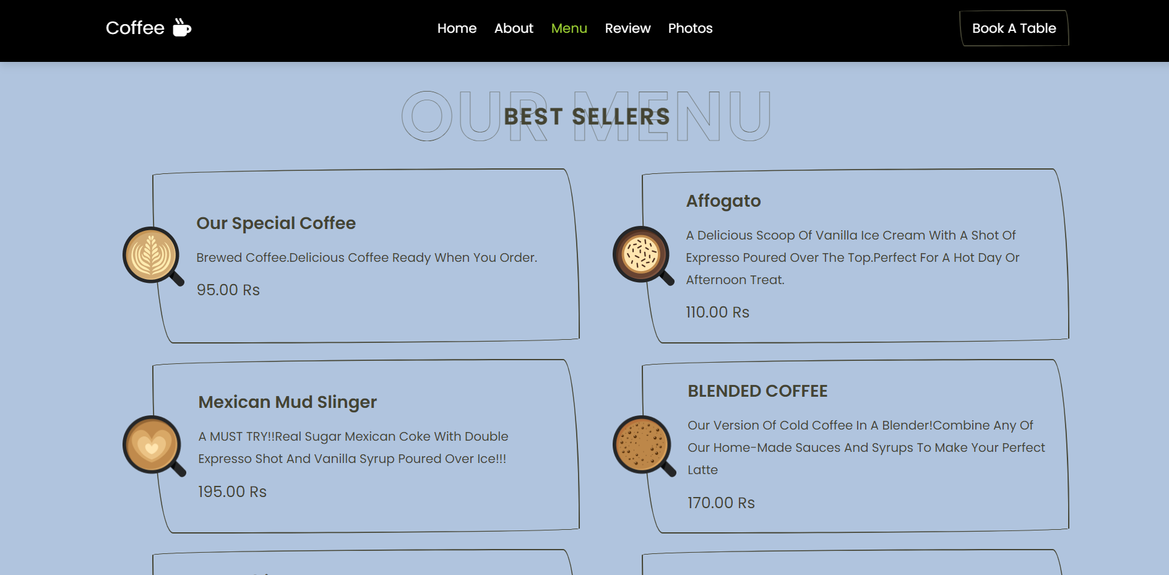

**REVIEW PAGE:**

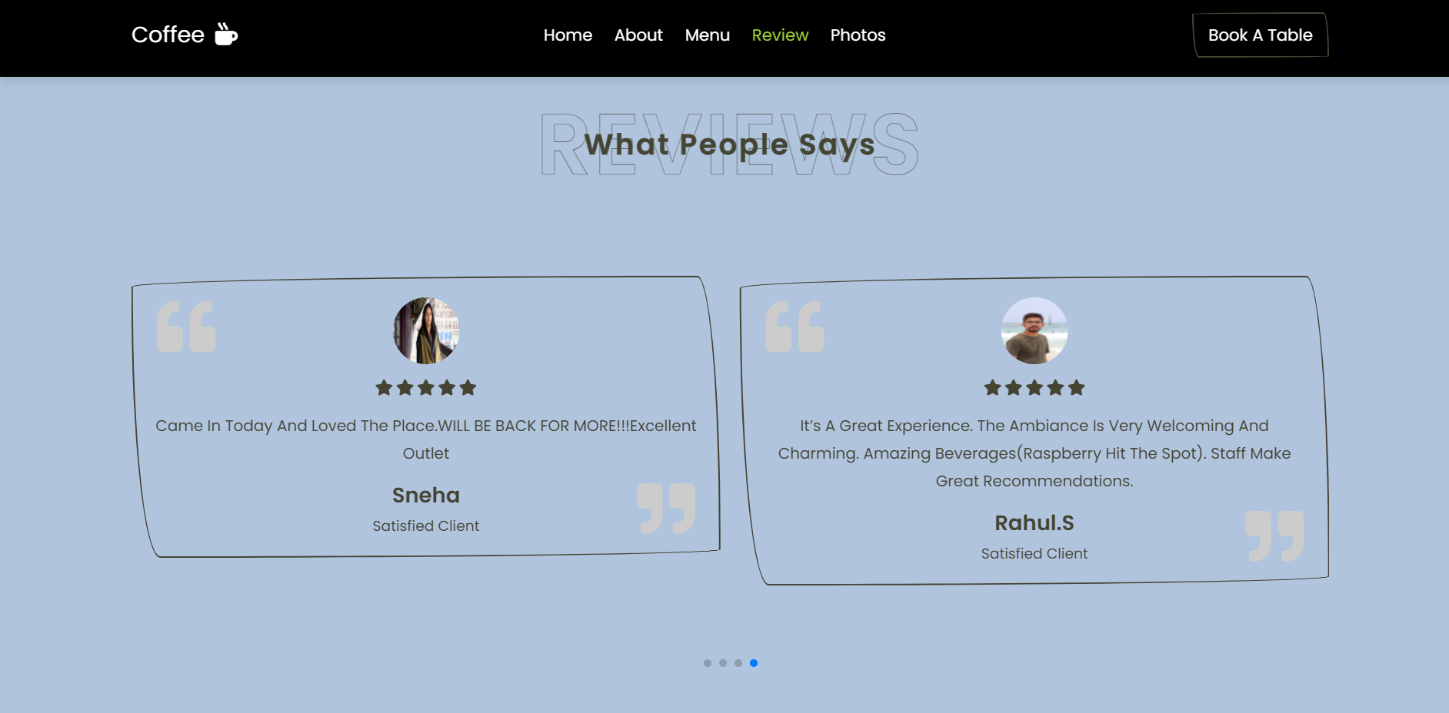

**BOOKING SECTION:**

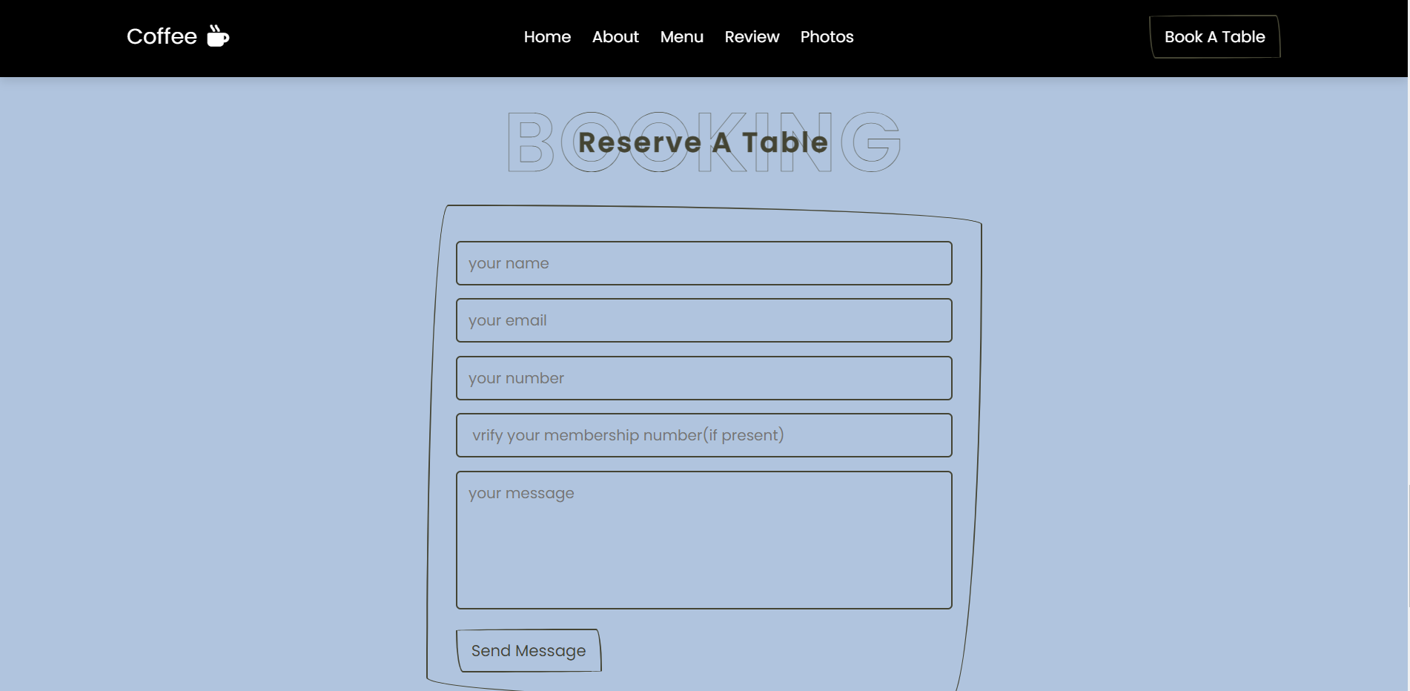

**PHOTOS:**

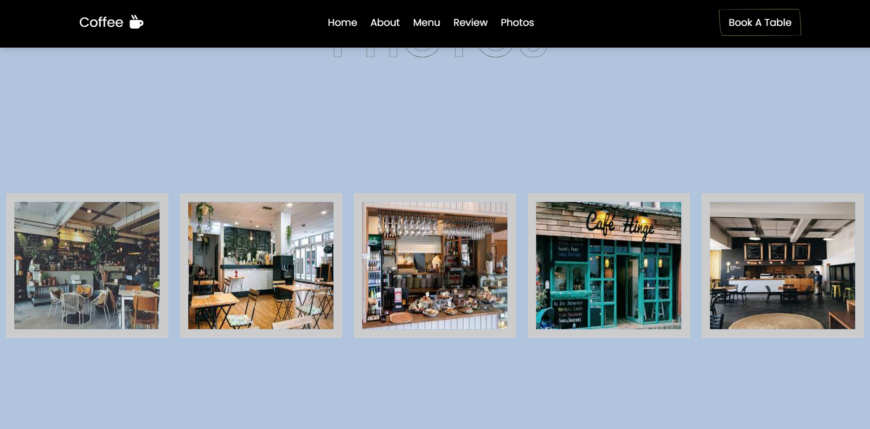

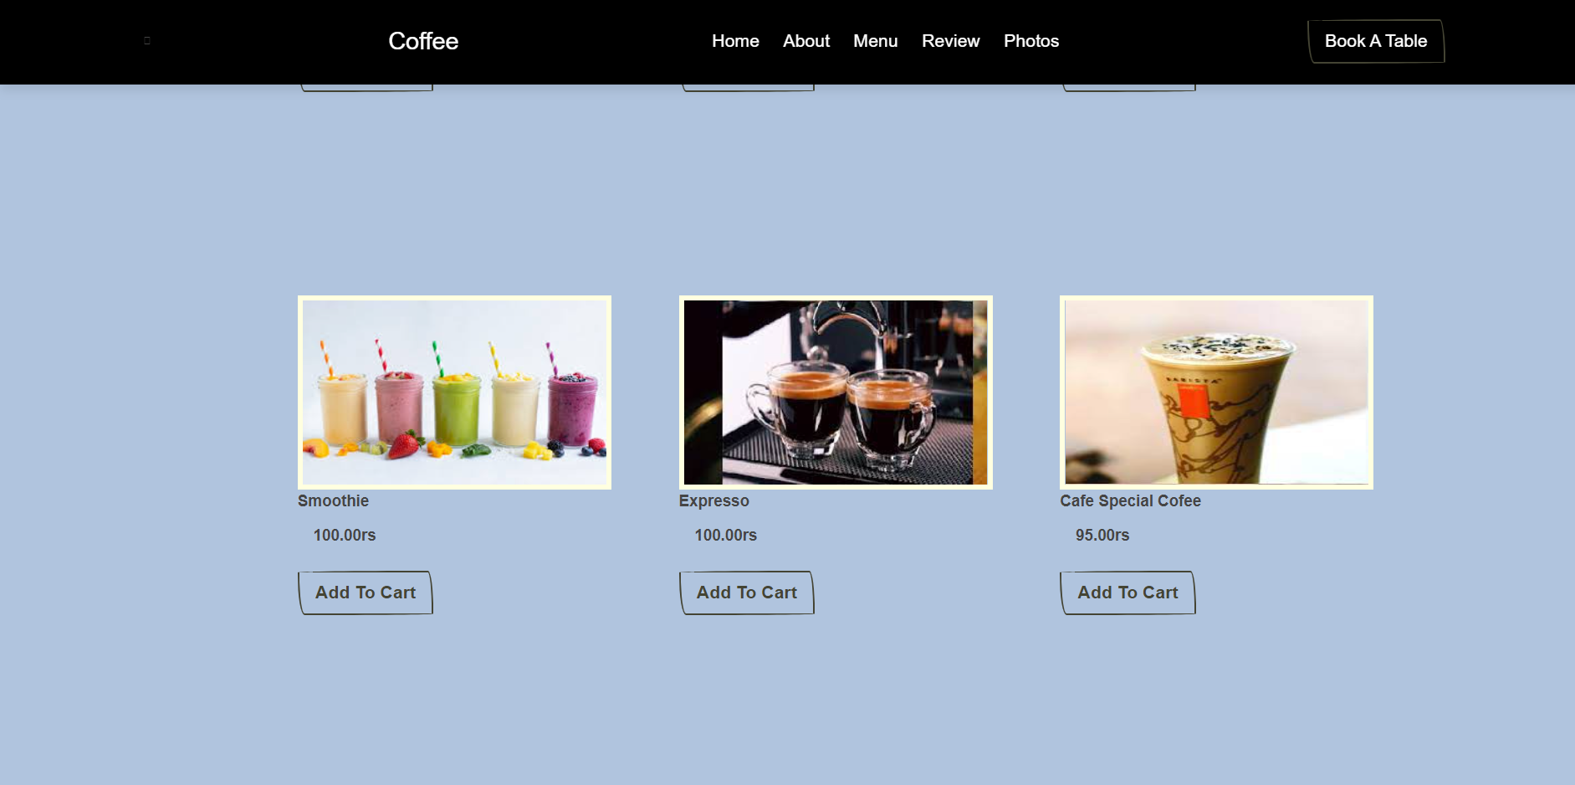

**CONCLUSION**

1. The purpose of this project is to book or reserve the table in advance for customers.
2. We just took up this project as we were interested and wanted to learn about it. Through this project ,we learnt a lot about the uses of different programming languages like html, css and javasrcipt and their applications in real life.
3. Also this is very simple and effective idea which can be used in many places like restaurants
4. Nowadays in this generation every work is required to be done in an easy way to efficiently use time and effort yet still having a productive report.
5. Café industry is one of the fastest growing industry.
6. The old system does not serve the customers in a better way. The new system keeps proper records of customers for security purposes.
7. We have learnt how to make a system user friendly.

**FUTURE SCOPE**

1. This system will help to manage and run the café shop systematically.
2. A table reservation is an arrangement made in advance to have a table available at a café or restaurants.
3. In this system we will provide a website that can be used by café’s employee to take order and reserve the table in advance.
4. So that owner of café can evaluate the whole system.
5. The food ordering process easier for customers as well as for café owners. Less processing time means less waiting time for food orders.
6. Live order tracking. It is very easy to customize the food order.
7. The system generates types of information that can be used for various purposes.
8. Be easy to understand by the user and operator.
9. Different advantages of online reservation systems:

Provide greater convience for customers

Reduce the risk of human error

Keep hosts focused on the task at hand

Optimize staffing

Improve cancellation information

Capture customer information

**BIBLIOGRAPHY**

1. We are interested in doing this project by referring below website: <https://www.w3schools.com/js/>
2. It creates enthusiasm in the customers to visit café.